**TimeSheet Tables**

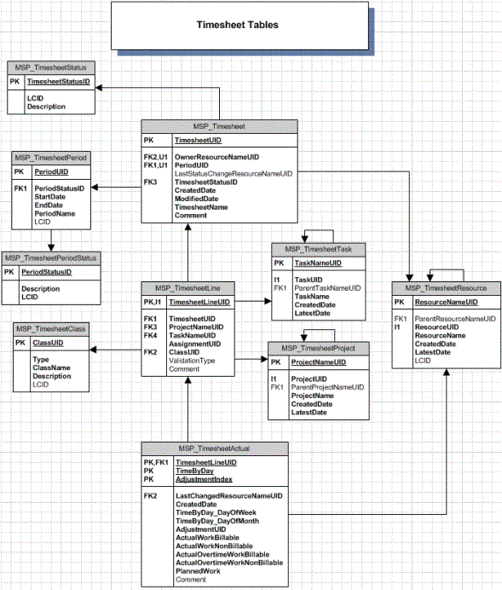

This is a time table so employees can locate information and do work with all the information they need.